Answers ----Test 1: Book search
- Land (title key word) --- Law (title key word) --- Dixon (author surname). As you can see you do not need to add many words but simply identifiable ones. You can also add the year to your search words e.g 2021. The first result is a 2018 physical and online edition of the book.
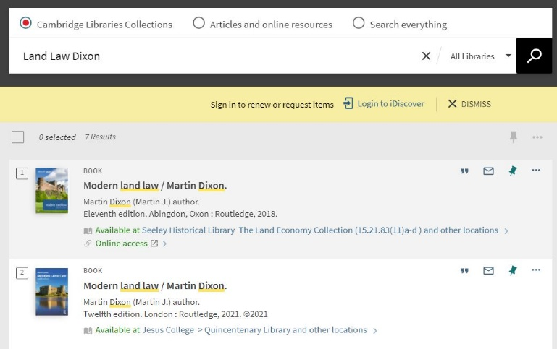
- Filters used were “Christ’s Library”. Once the filters are added, look at the information of your results. As you can see from the image above, the second result is the 2021 edition of the book. Filter more if the result is not in your top three results.
The actual entry has “Jesus College” as the example library but when you click on the book information it shows multiple libraries having a copy of the book, including Christ’s Library.

- During the making of this test, one copy is on loan and no one has recalled it for borrowing (“0 requests”). Copy 1 is a reference copy so not borrowable but can be consulted in the library. (see image below).
- The “classmark” for “Modern Land Law:2021” is KD 829.D59 2020 and it is situated on Floor 2 of Christ’s library (see image below). A classmark is a letter-number code given to each library book. You will need the classmark so you can find the book on the shelf.

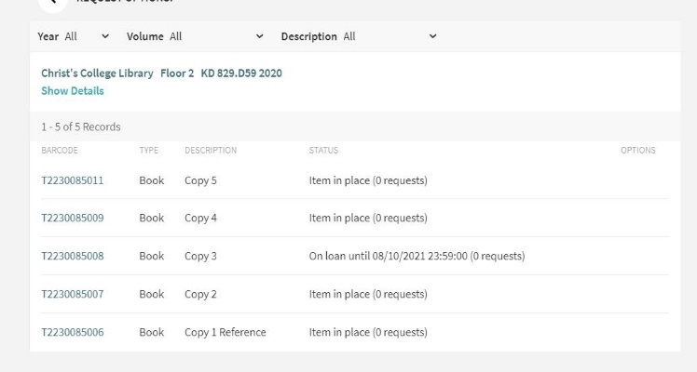

- In the book record, under the title, you will find the “Send to” section which has the subsection “Citation”. From there you can use iDiscover to create a reference based on the referencing style of your department. The referencing style for this example is “Chicago Style”.
- Under the book information either by using the ellipsis or entering the book information record you can find all the extra features of iDiscover including emailing book information.
Log into your iDiscover account by using your Raven password. Then while you are in the book record you want, use the “pin” symbol to save your book information. The information will stay saved in your library account profile.

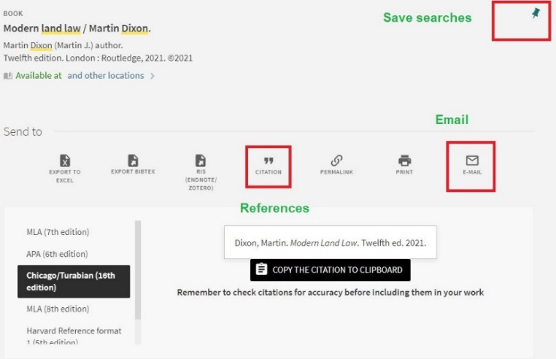

Answers ----Test 2: Ebook search
- I used “Fletcher History Architecture” as my search words. You can use any other identifiable words like “Sir Banister”. If you added the date “2018” as part of your search, please continue to answer 3.
- I used the filter “Christ’s Library”. The results show that the top record is the book I am looking for but not the year I am looking for. Christ’s holds an earlier edition (1996) of the physical copy.
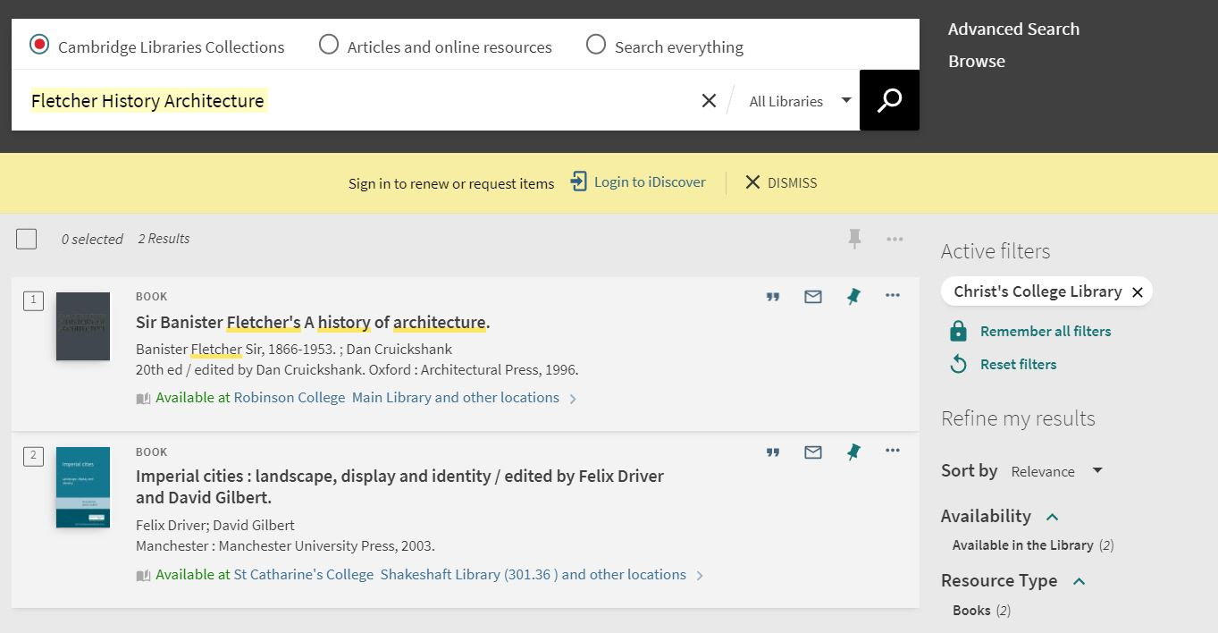

- A physical copy is not the only way you can access a book. In the example below I further filter by date to make sure the 2018 copy is not available. Filtering by date shows me the edition I need as an ebook. The second result is Volume 1 and the date of publication is in the record.
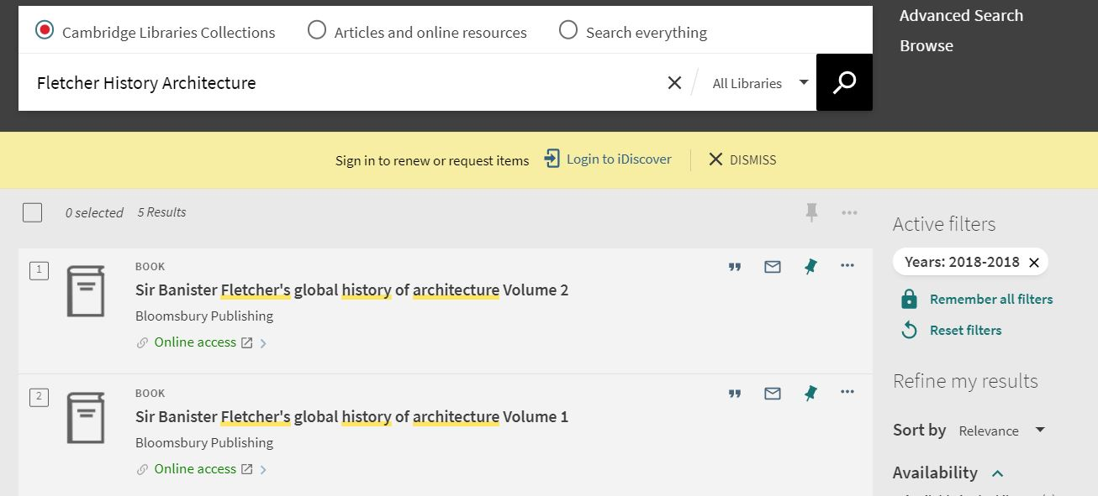
Clicking on the online access link takes you to the host institution where you can print or read online the individual chapters of volume 1. You may need your Raven password to access the host site.
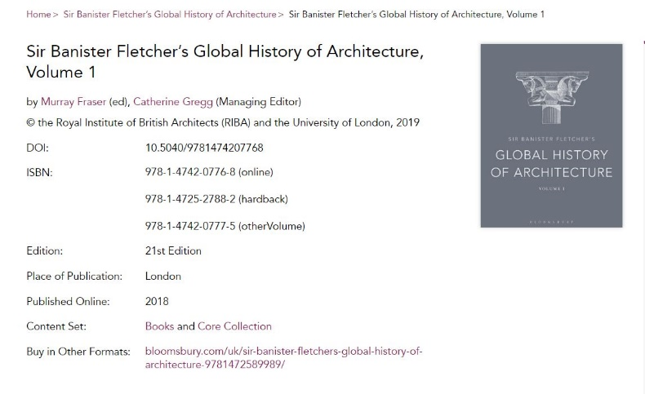
- Are you on the right chapter? The first line of the “Architecture chapter” is “Biblical and Greek sources have made Babylon one of the better-known cities of the ancient Middle East”.

Answers ----Test 3: Journal search
A "periodical" is any publication that comes out regularly or occasionally (i.e. periodically). A "journal," or "scholarly journal," is a scholarly periodical aimed at specialists and researchers. Articles are generally written by experts in the subject, using more technical language. They contain original research, conclusions based on data, footnotes or endnotes, and often an abstract or bibliography.
- Just from the reference I can see that this is a journal .
Morson, Gary Saul.: author
"Tolstoy's Absolute Language”: Title of article within the journal
." Critical Inquiry : Journal General title
7.4 (1981): Issue number (7) and sub-issue (4) and year of publication
667-87. : Pages within journal to find “Tolstoy's Absolute Language”

- For this I can directly go to journal search on iDiscover and search under "Tolstoy's Absolute Language”. I also minimised my search to only include “Articles and online resources”.

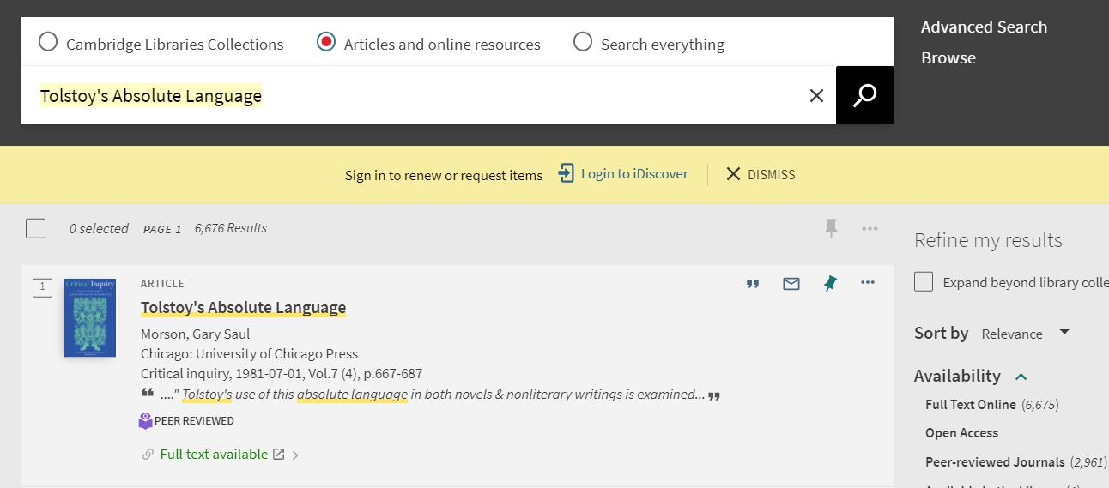
Click on the “Full text available” to take you directly to the article.
- Yes, you can download the entire article as a PDF. This specific host site allows you to download but others host sites may have restrictions.

