Answers ----Test 1: Book search
- As you can see you do not need to add many words but simply identifiable ones. This brings quite a few results. This is normal as these words are crosschecked with all the records on the catalogue.
- To narrow your results to make it relevant to you, you need to use filters. Filters used were “Christ’s Library”. Once the filters are added, look at the information of your results. During the making of this test, there were two results of two different books. The second result is the one that corresponds to your book.
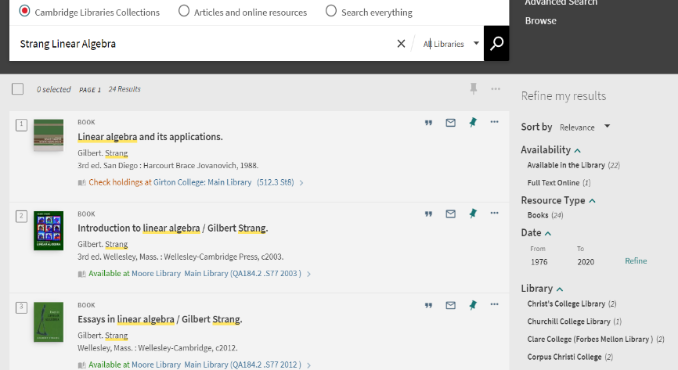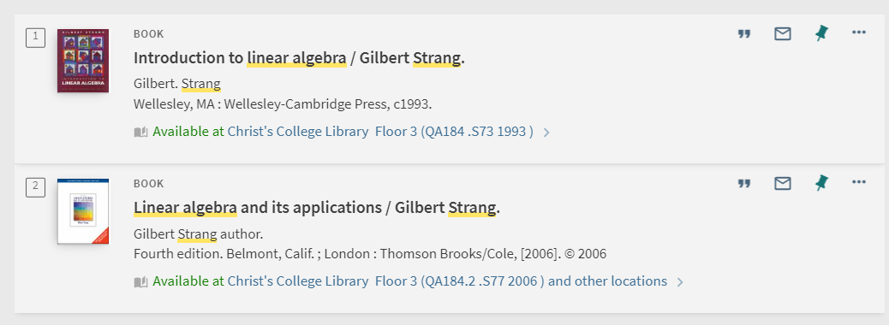
Make sure you have the right one
This is an example library
Filter for Christ’s

- Click on the title and it will take you to the book’s record where you can find information on where to find a physical copy in the library and if it is available. It will not always say “Available at Christ’s” as this is only an example set by iDiscover.
- You will find many libraries holding a physical copy of this book. Click on Christ’s to find the information for our library (as seen below)
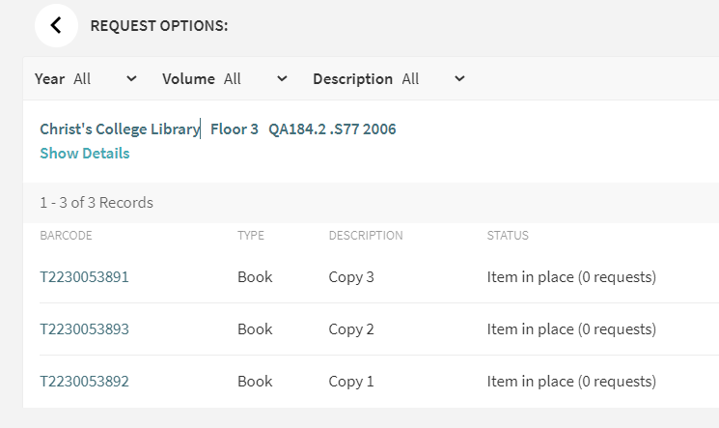
Item is available
Information you need to physically find the book
- During the making of this test, the library holds 3 copies of the same book and they are all available for borrowing.
- To find the book in the library, you will need to note down the “classmark” and location. A classmark is a letter-number code given to each library book. For this book it is “QA 184.2.S77 2006” on floor 3 of the library.

Login to your iDiscover account and save your items
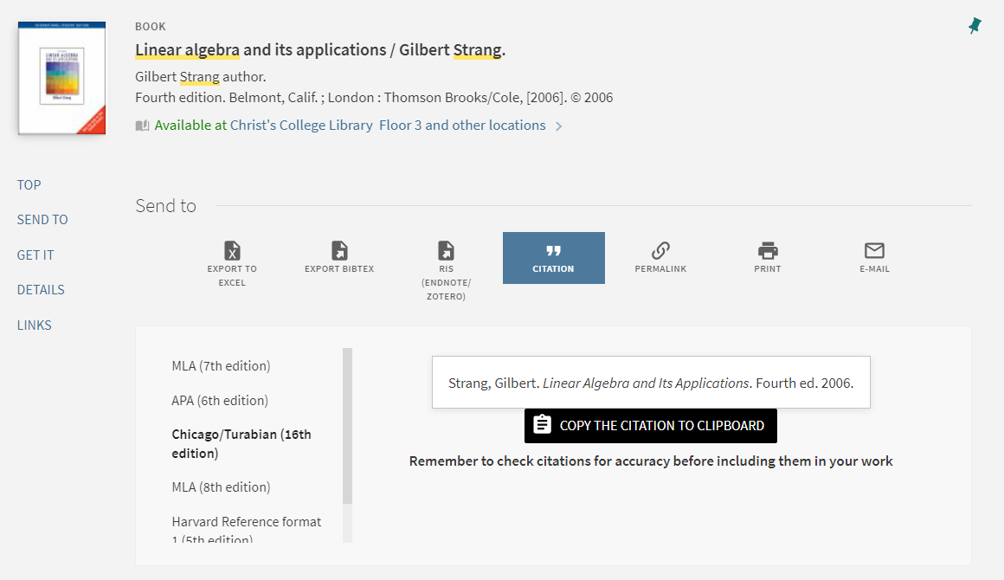
Choose your reference style based on your subject guidelines.

- In the book record, under the title, you will find the “Send to” section which has the subsection “Citation”. From there you can use iDiscover to create a reference based on the referencing style of your department. The referencing style for this example is “Chicago Style”.
- Under the book information either by using the ellipsis or entering the book information record you can find all the extra features of iDiscover including emailing book information.
Log into your iDiscover account by using your Raven password. Then while you are in the book record you want, use the “pin” symbol to save your book information. The information will stay saved in your library account profile.

Answers ----Test 2: Ebook search
- A physical copy is not the only way you can access a book. You can search by “ Cambridge Libraries Collections” or “Article and online resources”. By choosing “Article and online resources” you are limiting your search to e-resources
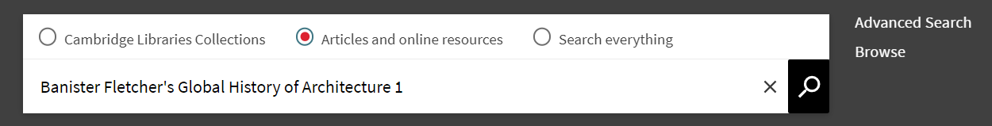

- In the example below I entered my identifiable words in the search engine. This brought too many results. As with any resource, I need to further filter.
- I filtered by date. This successfully narrowed down my results to volume 1 2018 copy. You can filter by many options such as “Availability” or “Date from-to”
Filter to narrow down results
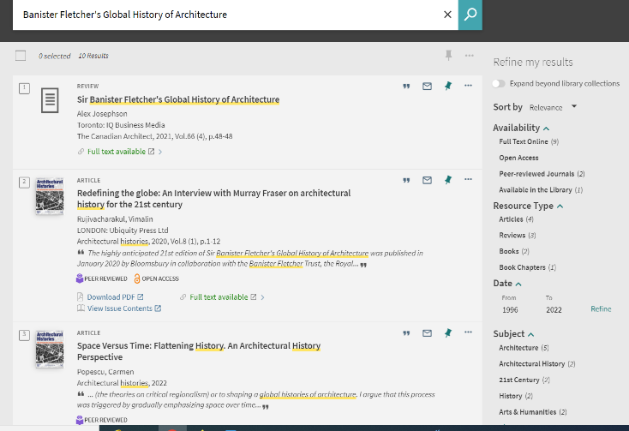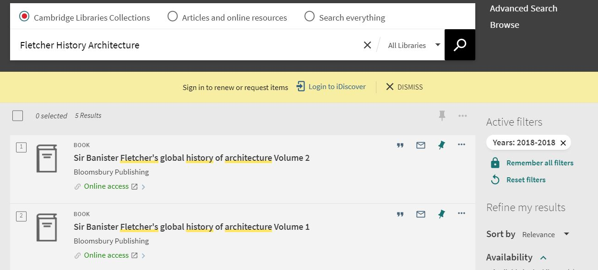
I additionally filtered by date
4.Clicking on the online access link takes you to the host institution where you can print or read online the individual chapters of volume 1. You may need your Raven password to access the host site. This is an example with different access and ways to view and interact with the ebook.
This example has a chapter which you can print, download or share
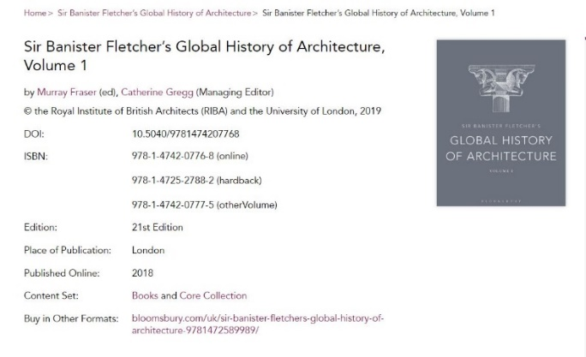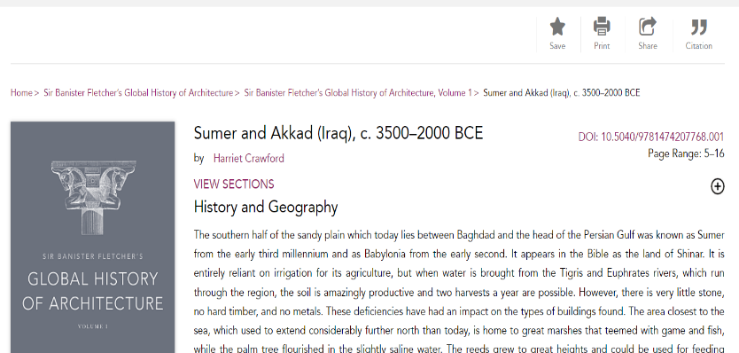
5.Are you on the right chapter? The first line of the “Architecture chapter” is “Biblical and Greek sources have made Babylon one of the better-known cities of the ancient Middle East”.
6.This ebook can also be found as a physical copy at Christ’s library. Our library still provides both physical and electronic copies of many books in our collections.

Answers ----Test 3: Journal search
A "periodical" is any publication that comes out regularly or occasionally (i.e. periodically). A "journal," or "scholarly journal," is a scholarly periodical aimed at specialists and researchers. Articles are generally written by experts in the subject, using more technical language. They contain original research, conclusions based on data, footnotes or endnotes, and often an abstract or bibliography.
Just from the reference I can see that this is a journal .
Morson, Gary Saul.: author
"Tolstoy's Absolute Language”: Title of article within the journal
." Critical Inquiry : Journal General title
7.4 (1981): Issue number (7) and sub-issue (4) and year of publication
667-87. : Pages within journal to find “Tolstoy's Absolute Language”

- For this I can directly go to journal search on iDiscover and search under "Tolstoy's Absolute Language”. I also minimised my search to only include “Articles and online resources”. Click on the “Full text available” to take you directly to the article.

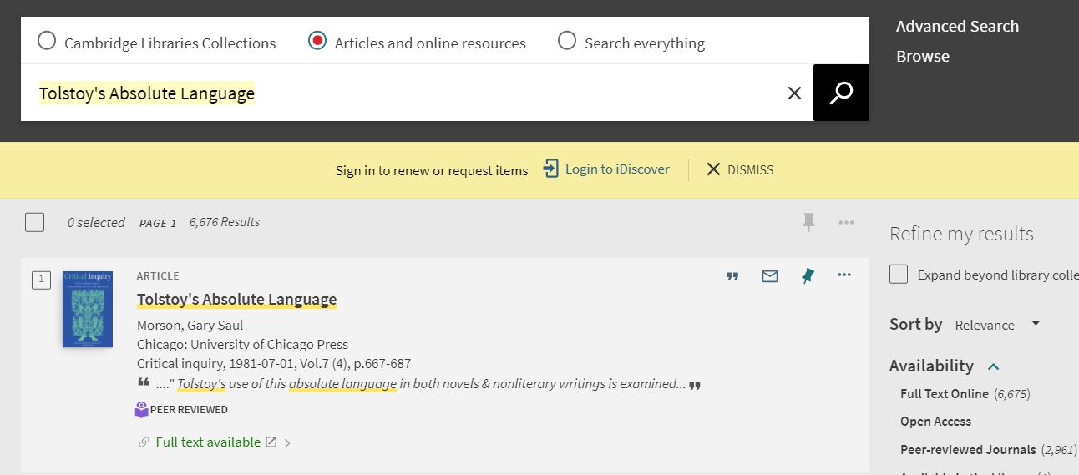

2.Yes, you can download the entire article as a PDF. This specific host site allows you to download but others host sites may have restrictions.
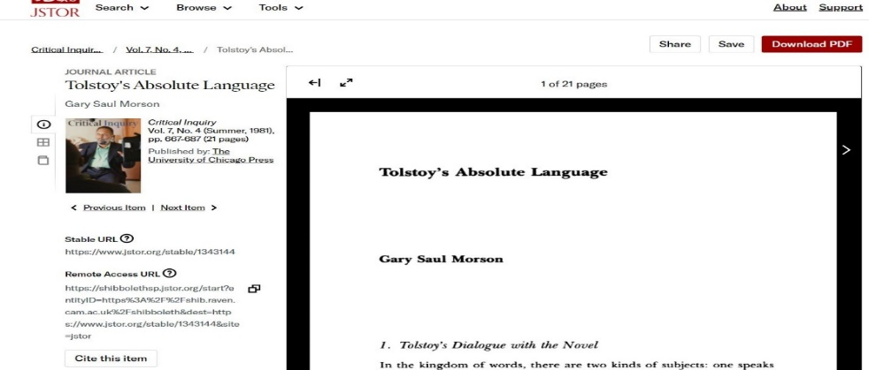
- If you still are not able to find your article, it might be that Cambridge libraries does not subscribe to it. Sometimes if you wish to be assured that it is not actually available you can search by the individual journal. iDiscover will let you know which parts of the journal are available and if you have access to them. For this example, you will have to look under “Critical enquiry” Issue number (7) and sub-issue (4) and year of publication and then find the individual pages. Keep in mind it is not always a straightforward process and needs more searching to find the right issue.
